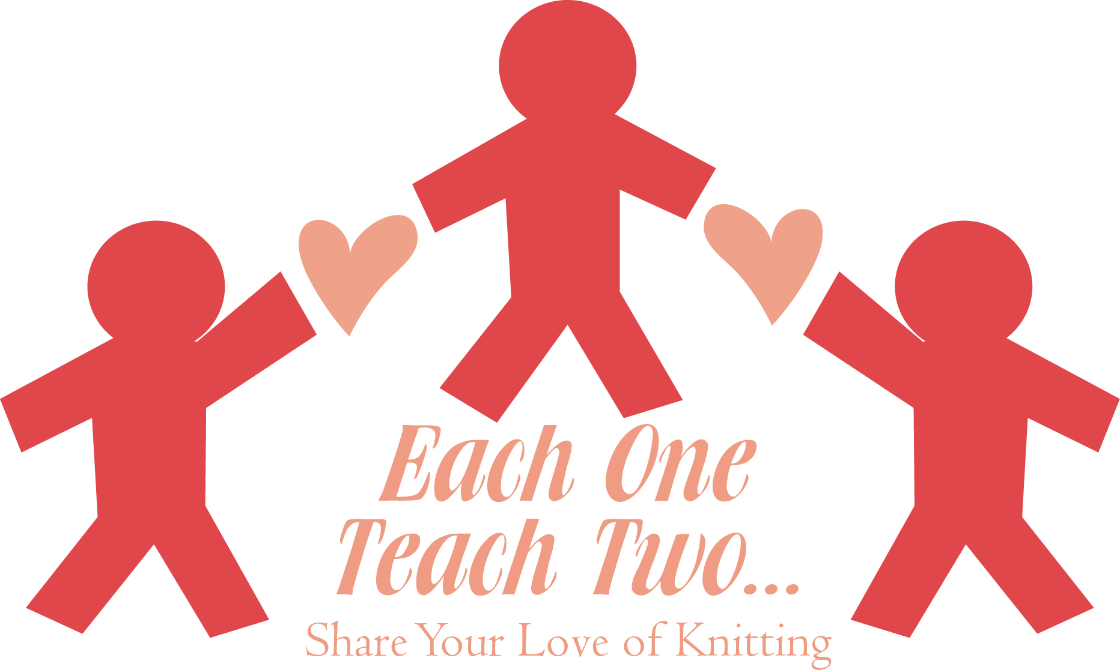
Each One Teach Two

This certifies that
is now qualified to be known officially as a knitter; is granted all rights and
privileges for the use of yarn and needles in a fun and creative manner;
and is authorized to share this new talent with at least two others.

Signed Date, Place

